# Task – 08 (MySQL)

The MySQL shell commands:

* Create IMDB database

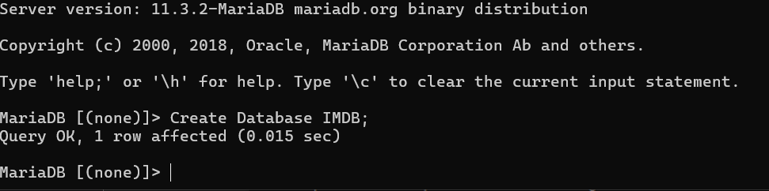

* USE IMDB:

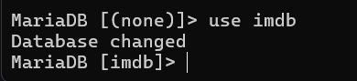

* Create Table to store information about movie:

CREATE TABLE Movie (movie_id INT PRIMARY KEY, title VARCHAR(70), release_date DATE);



* Add data for movie:

INSERT INTO Movie (movie_id, title, release_date) VALUES:

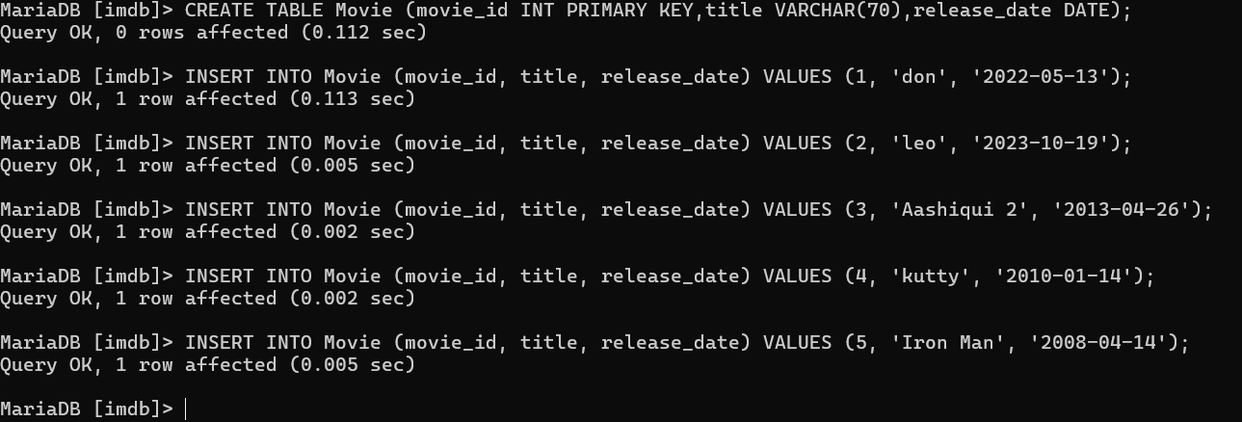

* Table to store media related to movies (images or videos):

CREATE TABLE Media (media_id INT PRIMARY KEY,movie_id INT,media_type ENUM('image', 'video'),media_url VARCHAR(100),FOREIGN KEY (movie_id) REFERENCES Movie(movie_id));

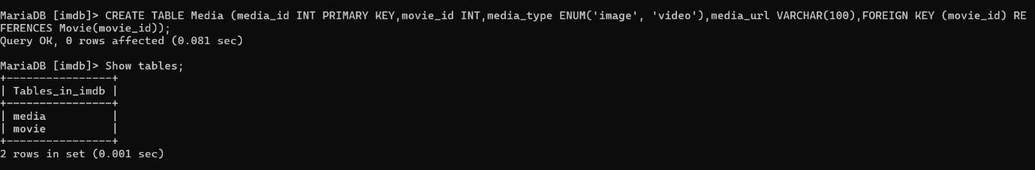

* Add media for movies:

INSERT INTO Media (media_id, movie_id, media_type, media_url) VALUES

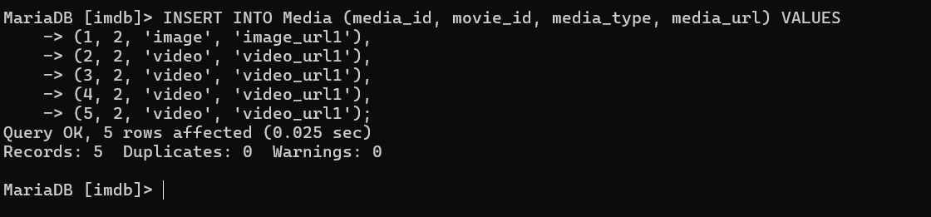

* Table to store information about genres:

CREATE TABLE Genre (genre_id INT PRIMARY KEY,genre_name VARCHAR(50));



* Add genres for movies:

INSERT INTO Genre (genre_id, genre_name) VALUES

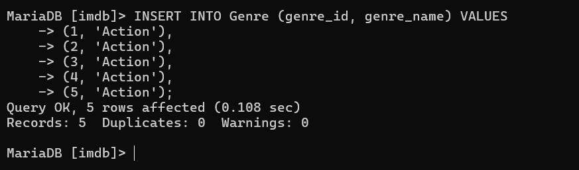

-- Table to associate movies with genres:

CREATE TABLE MovieGenre (movie_id INT,genre_id INT,PRIMARY KEY (movie_id, genre_id),FOREIGN KEY (movie_id) REFERENCES Movie(movie_id),FOREIGN KEY (genre_id) REFERENCES Genre(genre_id));



* Associate movies with genres:

INSERT INTO MovieGenre (movie_id, genre_id) VALUES

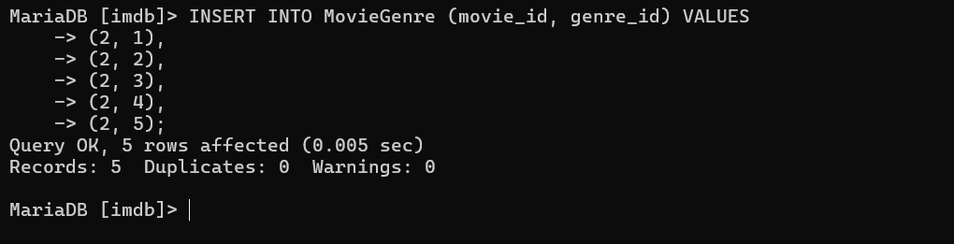

* Table to store information about reviews:

CREATE TABLE Review (review_id INT PRIMARY KEY, movie_id INT, user_id INT, rating INT, review_text TEXT, FOREIGN KEY(movie_id) REFERENCES MOVIE(movie_id));



* Add reviews for movies:

INSERT INTO Review (review_id, movie_id, user_id, rating, review_text) VALUES

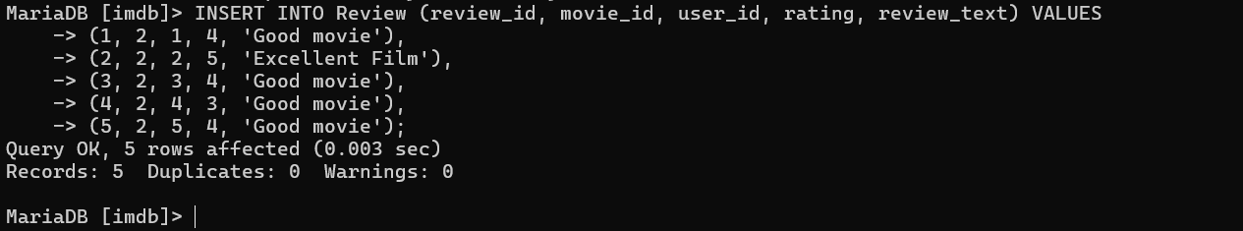

Select * from review

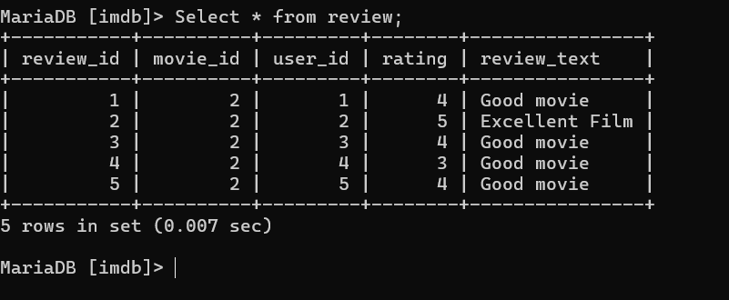

* Table to store information about artists:

CREATE TABLE Artist (artist_id INT PRIMARY KEY,name VARCHAR(20));

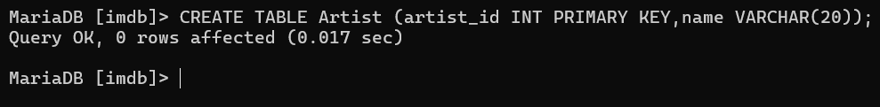

* INSERT INTO Artist (artist_id,name) VALUES

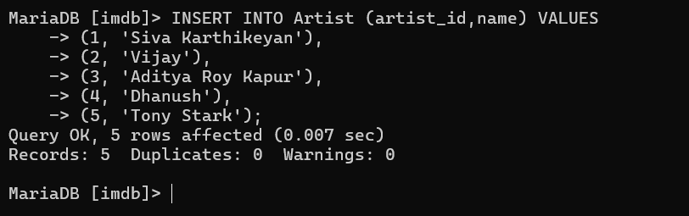

* Use select * from table_name to get inserted values:

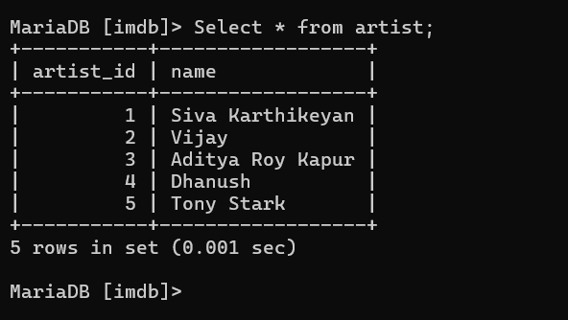

* Table to store information about skills:

CREATE TABLE Skill (skill_id INT PRIMARY KEY,skill_name VARCHAR(50));



INSERT INTO SKILL (skill_id,skill_name) VALUES (1,'Fantastic comic timing'), (2,'High Self Esteem'), (3,'Life Skills from a Struggler'), (4,'Fantastic comic timing'), (5,'A hardworking actor');



* Table to associate artists with skills:

CREATE TABLE ArtistSkill (artist_id INT,skill_id INT,PRIMARY KEY (artist_id, skill_id),FOREIGN KEY (artist_id) REFERENCES Artist(artist_id),FOREIGN KEY (skill_id) REFERENCES Skill(skill_id));



INSERT INTO ArtistSkill (artist_id,skill_id) VALUES

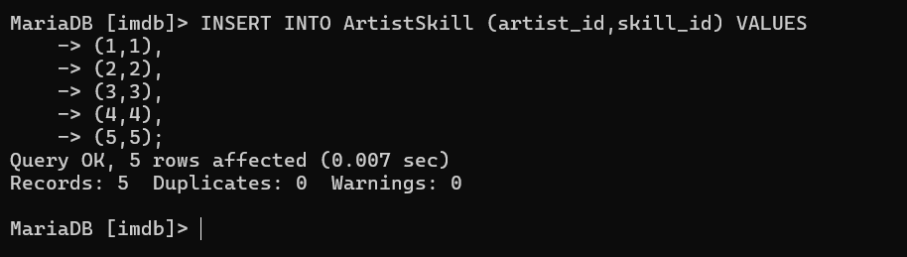

* Table to store information about roles in movies:

CREATE TABLE Role (role_id INT PRIMARY KEY,role_name VARCHAR(50));

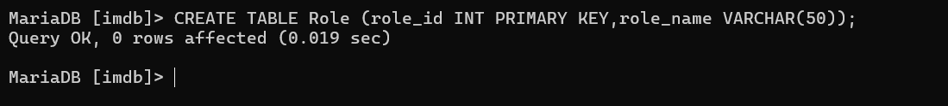

INSERT INTO Role (role_id,role_name) VALUES (1,'Chakaravarthi'),(2,'Leo Das'),(3,'Rahul'),(4,'Kutty’),(5,'Tony’);

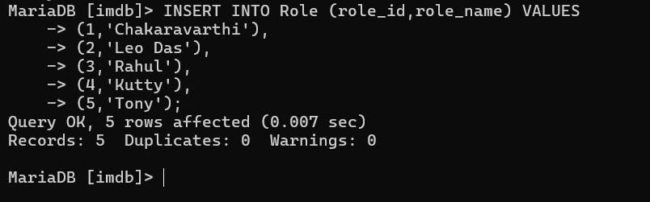

* Table to associate artists with roles in movies:

CREATE TABLE ArtistRole (artist_id INT,role_id INT,movie_id INT,PRIMARY KEY (artist_id, role_id, movie_id),FOREIGN KEY (artist_id) REFERENCES Artist(artist_id),FOREIGN KEY (role_id) REFERENCES Role(role_id),FOREIGN KEY (movie_id) REFERENCES Movie(movie_id));

